**Test Case** **0013**

**System:** VirtuCardsClient & VirtuCardsHost

**Description:** Tests that the host can create a Freeplay game.

**Severity:** 3

**Instructions**

**Test 1**

1. Start VirtuCardHost application
2. Click the button labeled “Sign in”
3. Enter “virtucards01@gmail.com” into the text input labeled “Enter email…”
4. Enter “Testing1” into the text input labeled “Enter password…”
5. Press the button labeled “Login”
6. A window should appear saying “Login Success”
7. Press the OK button that appears on that window
8. Click the dropdown menu to view options
9. Scroll down and select the Freeplay option
10. Click the create game button

**Expected Result:** Once the host is redirected to a waiting room, the game-mode should be displayed as Freeplay.

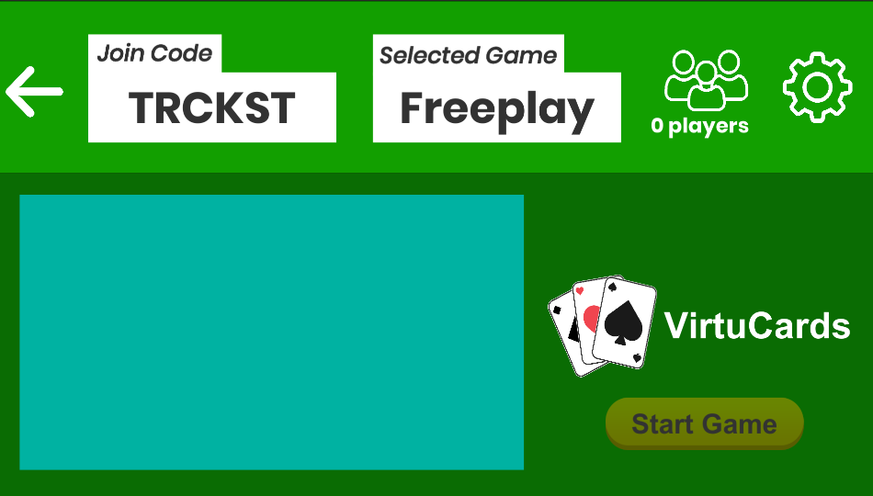

* You can see that Freeplay is displayed as the selected game

**Test 2**

1. Start VirtuCardHost application
2. Click the button labeled “Sign in”
3. Enter “virtucards01@gmail.com” into the text input labeled “Enter email…”
4. Enter “Testing1” into the text input labeled “Enter password…”
5. Press the button labeled “Login”
6. A window should appear saying “Login Success”
7. Press the OK button that appears on that window
8. Click the dropdown menu to view options
9. Scroll down and select the Testgame option
10. Click the create game button

**Expected Result:** Once the host is redirected to a waiting room, the game-mode should be displayed as Testgame

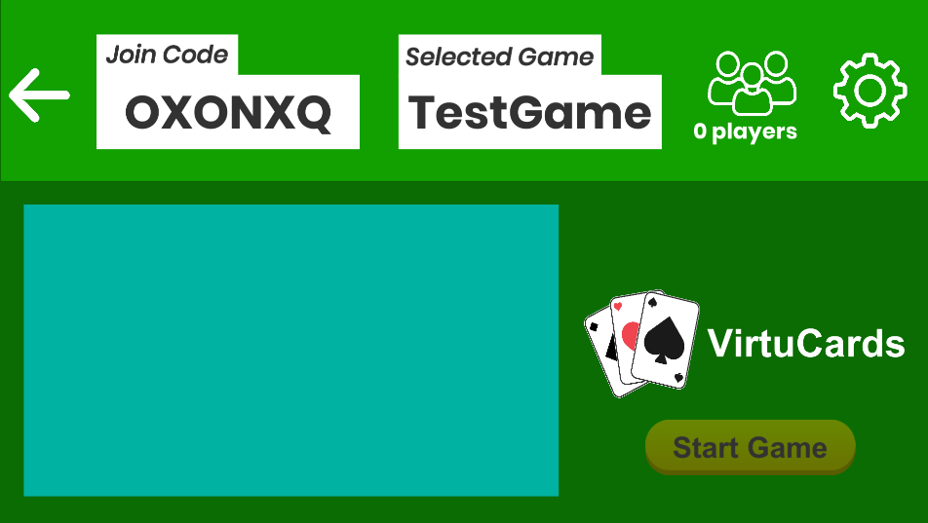

* You can see that the selected game is TestGame

1. In the waiting room, click the back arrow to go back to select game mode
2. Click the dropdown menu to view options
3. Scroll down and select the Freeplay option
4. Click the create game button

**Expected Result:** Once the host is redirected to a waiting room, the game-mode should be displayed as Freeplay.

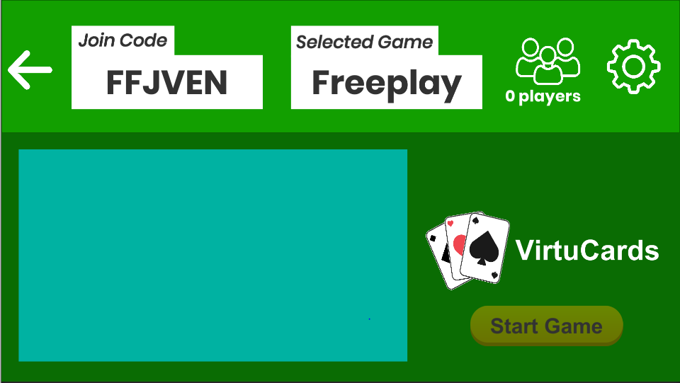

* You can see that Freeplay is displayed as the selected game

**Test 3**

1. Start VirtuCardHost application
2. Click the button labeled “Sign in”
3. Enter “virtucards01@gmail.com” into the text input labeled “Enter email…”
4. Enter “Testing1” into the text input labeled “Enter password…”
5. Press the button labeled “Login”
6. A window should appear saying “Login Success”
7. Press the OK button that appears on that window
8. Uncheck the box that says allow host to join
9. Click the dropdown menu to view options
10. Scroll down and select the Freeplay option
11. Click the create game button

**Expected Result:** Once the host is redirected to a waiting room, the game-mode should be displayed as Freeplay.

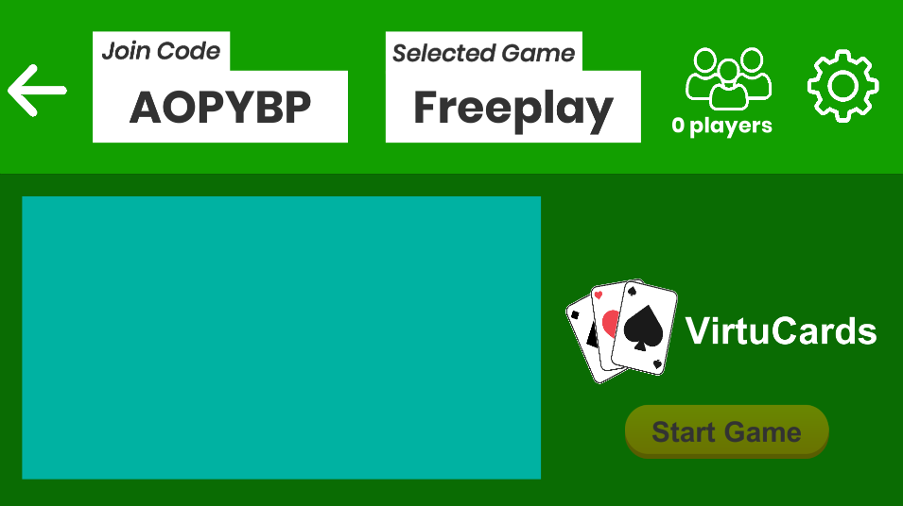

* Changing whether the host can join should not affect the output. You can see here that Freeplay is still properly displayed

**Test 4**

1. Start VirtuCardHost application
2. Click the button labeled “Sign in”
3. Enter “virtucards01@gmail.com” into the text input labeled “Enter email…”
4. Enter “Testing1” into the text input labeled “Enter password…”
5. Press the button labeled “Login”
6. A window should appear saying “Login Success”
7. Press the OK button that appears on that window
8. Click the settings button

**Expected Result:** You should be navigated to the settings screen

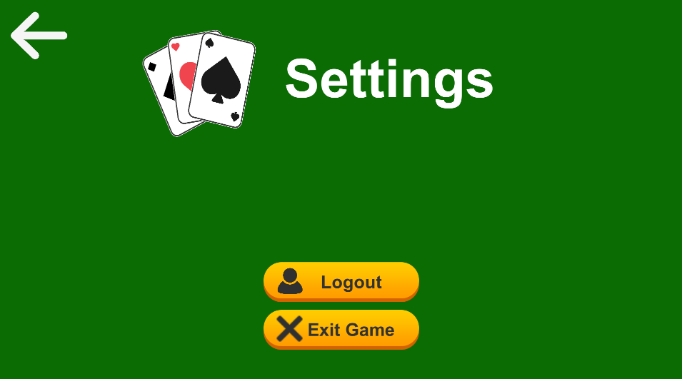

* This is what the settings page looks like after navigating to it

1. Click the back arrow on the settings screen
2. Click the dropdown menu to view options
3. Scroll down and select the Freeplay option
4. Click the create game button

**Expected Result:** Once the host is redirected to a waiting room, the game-mode should be displayed as Freeplay.

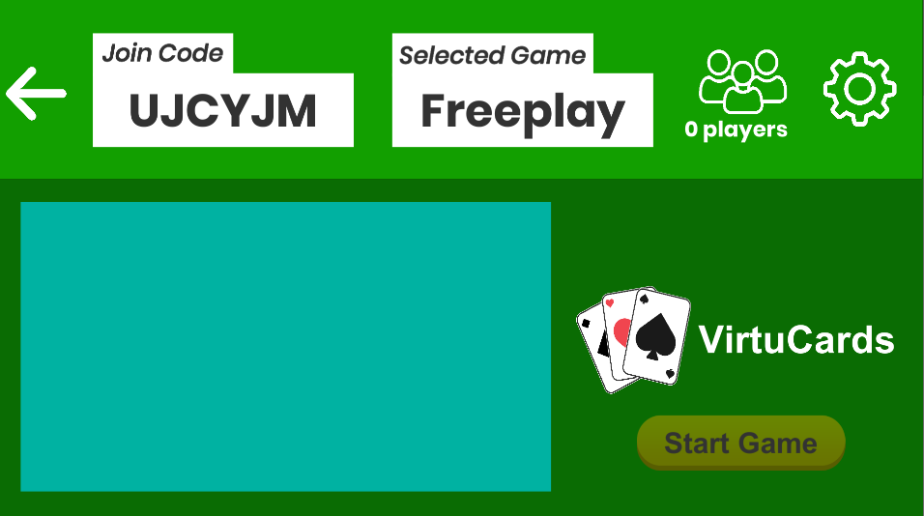

* Here you can see that the host was properly able to make a Freeplay game after navigating to the settings page first